Jo’rayev Mansur 215-19

5-laboratoriya ishi(5-variant)

Javascriptda factorialni hisoblovchi dastur tuzing

Index.html

<!DOCTYPE html>

<html lang="en">

<head>

    <meta charset="UTF-8">

    <meta http-equiv="X-UA-Compatible" content="IE=edge">

    <meta name="viewport" content="width=device-width, initial-scale=1.0">

    <title>5-6-7 Calculator</title>

    <link rel="stylesheet" href="./assets/css/index.css">

</head>

<body>

    <div class="container">

        <div class="box">

            <input  disabled   id="result" type="text">

            <input autocomplete="off" value="0" id="input" type="number">

            <div class="keys">

                <div onclick="typeFunc(1)" class="cell number">1</div>

                <div  onclick="typeFunc(2)" class="cell number">2</div>

                <div  onclick="typeFunc(3)" class="cell number">3</div>

                <div onclick="clearInput()" class="cell">C</div>

                <div  onclick="typeFunc(4)" class="cell number">4</div>

                <div  onclick="typeFunc(5)" class="cell number">5</div>

                <div  onclick="typeFunc(6)" class="cell number">6</div>

                <div onclick="jsCalc()" class="cell">!</div>

                <div  onclick="typeFunc(7)" class="cell number">7</div>

                <div  onclick="typeFunc(8)" class="cell number">8</div>

                <div  onclick="typeFunc(9)" class="cell number">9</div>

                <div onclick="handleEqual()" class="cell">=</div>

                <div class="cell"></div>

                <div  onclick="typeFunc(0)" class="cell number">0</div>

                <div class="cell"></div>

                <div class="cell"></div>

            </div>

        </div>

    </div>

</body>

<script src="./assets/js/js.js"></script>

</html>

Js.js fayli

function fact(x){

    console.log(x)

    if(x<0) return NaN

    if(x==0) return 1

    return x\*fact(x-1)

}

var input = document.getElementById('input')

var result = document.getElementById('result')

function errorFunc(error){

    alert(error)

}

function jsCalc(){

    try {

        const answer = fact(parseInt(input.value))

        if( answer ==Infinity)throw new Error('Qiymat juda katta')

        input.value =answer

        console.log(input.value)

    } catch (error) {

        result.value = NaN

        errorFunc(error)

    }

}

function handleEqual(){

    result.value = input.value

}

function clearInput(){

    input.value=0

    result.value=null

}

function typeFunc(x){

    input.value = input.value\*10 + x

}

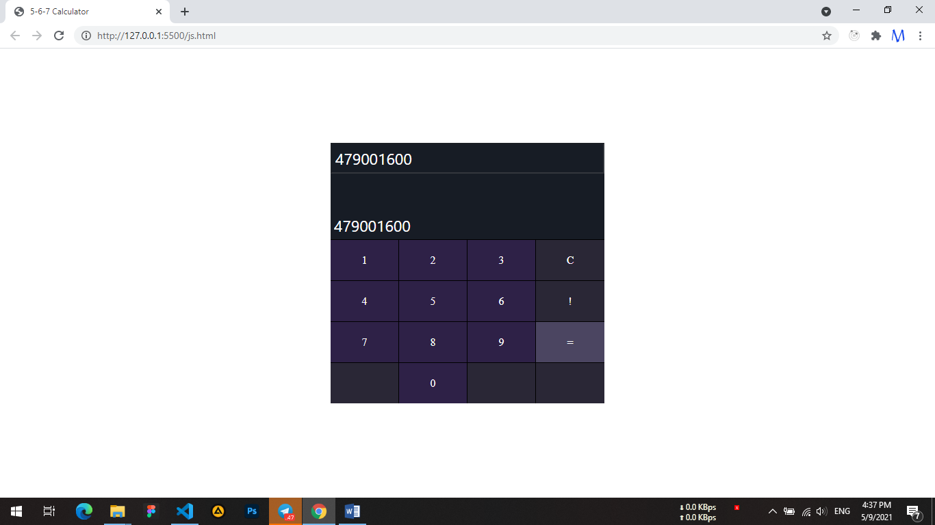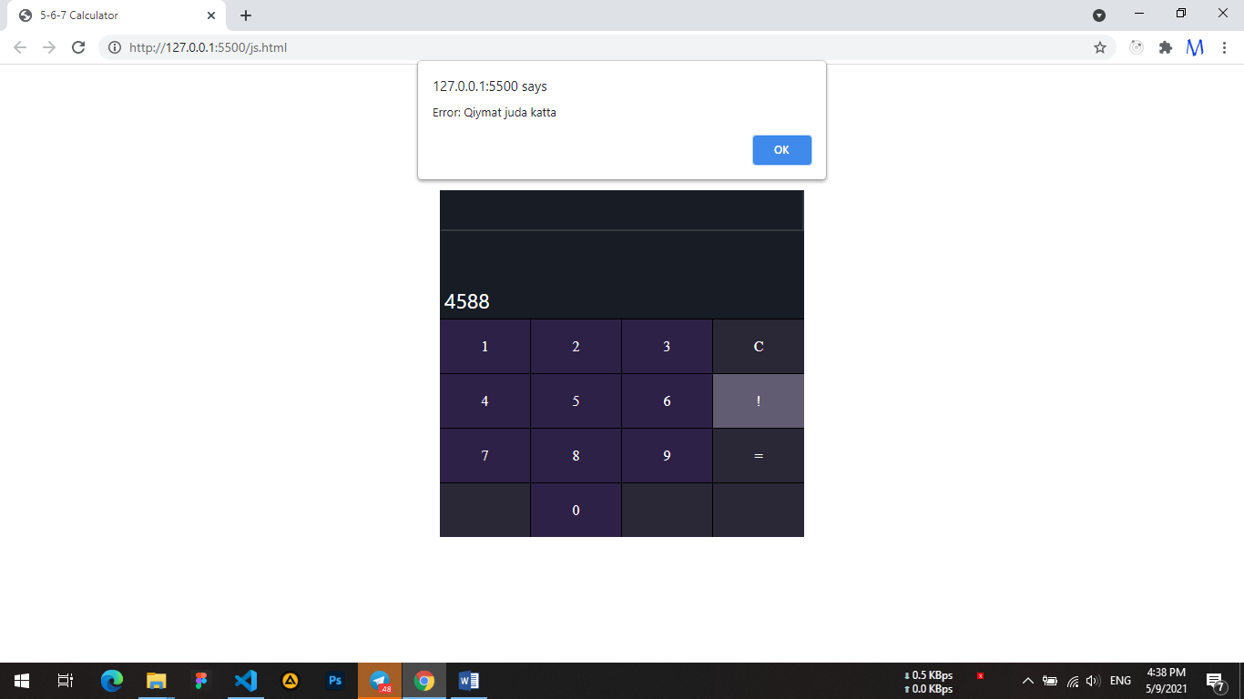

6-7 laboratoriya

5-laboratoriyada bajargan ishimizni Jquerydan foydalanib bajaramiz.

Jquery html

<!DOCTYPE html>

<html lang="en">

<head>

    <meta charset="UTF-8">

    <meta http-equiv="X-UA-Compatible" content="IE=edge">

    <meta name="viewport" content="width=device-width, initial-scale=1.0">

    <title>5-6-7 Calculator</title>

    <link rel="stylesheet" href="./assets/css/index.css">

</head>

<body>

    <div class="container">

        <div class="box">

            <input  disabled   id="result" type="text">

            <input autocomplete="off" value="0" id="input" type="number">

            <div class="keys">

                <div onclick="typeFunc(1)" class="cell number">1</div>

                <div  onclick="typeFunc(2)" class="cell number">2</div>

                <div  onclick="typeFunc(3)" class="cell number">3</div>

                <div onclick="clearInput()" class="cell">C</div>

                <div  onclick="typeFunc(4)" class="cell number">4</div>

                <div  onclick="typeFunc(5)" class="cell number">5</div>

                <div  onclick="typeFunc(6)" class="cell number">6</div>

                <div onclick="jsCalc()" class="cell">!</div>

                <div  onclick="typeFunc(7)" class="cell number">7</div>

                <div  onclick="typeFunc(8)" class="cell number">8</div>

                <div  onclick="typeFunc(9)" class="cell number">9</div>

                <div onclick="handleEqual()" class="cell">=</div>

                <div class="cell"></div>

                <div  onclick="typeFunc(0)" class="cell number">0</div>

                <div class="cell"></div>

                <div class="cell"></div>

            </div>

        </div>

    </div>

</body>

<script src="./assets/js/jquery-3.6.0.slim.min.js"></script>

<script src="./assets/js/jquery.js"></script>

</html>

E’tibor bersak index.html faylida faqat bitta o’zgarish qilamiz ya’ni jquery kutubxona faylini ulab quyamiz.

Jquery.js

function fact(x){

    console.log(x)

    if(x<0) return NaN

    if(x==0) return 1

    return x\*fact(x-1)

}

var input = $('#input')

var result =$('#result')

function errorFunc(error){

    alert(error)

}

function jsCalc(){

    try {

        const answer = fact(parseInt(input.val()))

        if( answer ==Infinity)throw new Error('Qiymat juda katta')

        input.val(answer)

    } catch (error) {

        result.val(NaN)

        errorFunc(error)

    }

}

function handleEqual(){

    result.val(input.val())

}

function clearInput(){

    input.val(0)

    result.val(null)

}

function typeFunc(x){

    input.val(input.val()\*10 + x)

}

